    - FOR ORD 10.09 (2020R3) NCDOT Connect WorkSpace Update Version 7.0.1

- For everyone’s awareness, there is an updated NCDOT Connect WorkSpace, Version 7.0.1, that is available for download and further testing during our ORD Implementation Initiative Pilot Project Phase. The update includes the following changes:
  - New Horizontal Alignment Annotation Groups – 3CPO
  - Modified, Updated and Created New Label Cells and Dimension Styles
  - Custom line styles converted, renamed, and reassigned to levels DGNLIB for each NCDOT Unit - Use new custom line style DGNLIB (RSC for backup and modification)
  - Created Batch Process (.bprc) file for each NCDOT Unit for future ORD version upgrades.
  - Deleted unused and obsolete fonts from WorkSpace
  - Transoft Solutions GuideSIGN Plus and AutoTURN Pro toolboxes activated
  - Updated NCDOT_Hydraulics WorkSpace
  - Updated NCDOT_Erosion_Control WorkSpace
  - Updated NCDOT_Geotechnical WorkSpace
  - Modified “ConfigurationSetup.cfg” - MICROSTATION_CONNECT_WORKSPACE-Beta.zip
  - Updated all WorkSpaces and training WorkSets files to 2020R3 (10.09.00.91) – Major Schema Change - excluding NCDOT_Structures (OpenBridge) and NCDOT_RailRoad (OpenRail)
- Note 1: The process noted below is a temporary way in the short term for setting up and testing the current version of the NCDOT Connect WorkSpace.
- Note 2: If you want to verify the version of the ZIP file of the NCDOT Connect WorkSpace before downloading it under its “Title” properties once you have right clicked on the link to check the properties (see screenshot below)

will need to change this screenshot below. . .
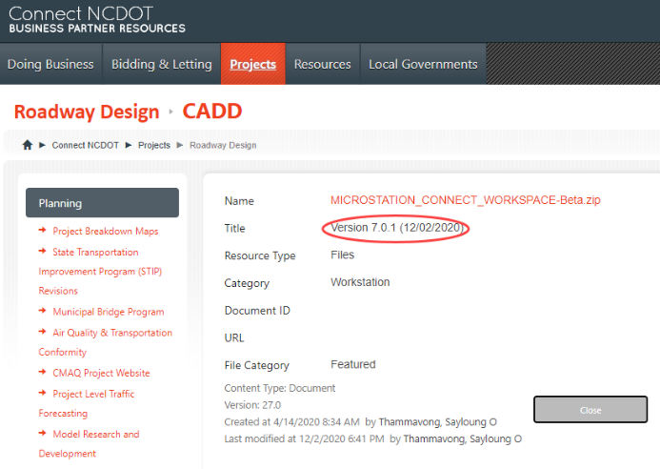
- See below for the general steps to update the current NCDOT Connect Workspace to the most recent Version for continued testing and use. Perform the NCDOT CONNECT WorkSpace update in the following sequence.
- Delete the entire “C:\MICROSTATION_CONNECT_WORKSPACE” folder.
- Delete the old desktop icons.
- Download the “MICROSTATION_CONNECT_WORKSPACE-Beta.zip” (see the link below)

https://connect.ncdot.gov/projects/Roadway/Training/MICROSTATION_CONNECT_WORKSPACE-Beta.zip

- Unzip (EXTRACT ALL) “MICROSTATION_CONNECT_WORKSPACE-Beta.zip” To the root C:\ drive.
- Copy the new desktop icons from the following WorkSpace folder:
  - C:\MICROSTATION_CONNECT_WORKSPACE\Configuration\WorkSpaces\DOT-US North Carolina\Desk
  - At a minimum, the following 3 icons should be copied to the desktop:
    - The NCDOT_WorkSets.inp (required)
    - NCDOT ALL (Loads all Unit’s Resources)
    - Any Unit Specific Desktop Icon

