Are you a professional in the world of engineering, architecture,
city planning, technology or a related field?

If yes, we need your support. NC Future Cities is looking for
Industry Professionals to be Virtual Mentors and Judges!
The Future City Competition engages more than 45,000 middle school students each year throughout the United States and abroad. Students repeatedly report that the program increases their motivation and excitement about STEM (Science, Technology, Engineering, and Math). In addition, students and teachers report a marked improvement in students’ 21st Century skills.
Future City starts with a question—how can we make the world a better place? To answer it, 6th, 7th, and 8th grade students imagine, research, design, and build cities of the future that showcase their solution to a citywide sustainability issue. Past topics include stormwater management, urban agriculture, public spaces, and green energy. The 2021-2022 theme is A Waste-Free Future. Teams will design a waste-free city using the principles of a circular economy.
Participants complete five deliverables: a 1,500-word city essay; a scale model (or multiple model segments) built from recycled materials; a project plan, a presentation video, and a Q&A session with judges. Regional winners represent their region at the international Finals. After completing Future City, student participants are not only prepared to be citizens of today’s complex and technical world, but also poised to become the drivers of tomorrow.
Visit the Future City Competition website to learn more.
Take a look at this Future City Competition Overview Video.
Click here to be a volunteer: Register - Future City® Competition

Why participate?
Students will have the opportunity to learn how to apply math, science, and technology to real-world engineering problems. Along the way they’ll discover engineering, uncover hidden talents, gain confidence, and flex their problem solving skills. We need your help. Get involved and volunteer!
Underserved Communities
Future City challenges students to tackle authentic, real-world problems and is accessible to every student, from the exceptional child to the gifted and talented. Female students, minority students, and low-income students from Title I schools all participate at record levels.
Student Outcomes
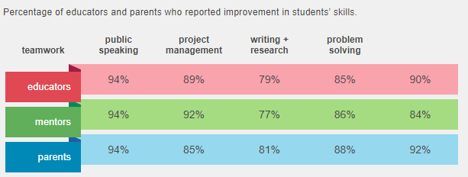
In 2015-2016 the Concord Evaluation Group completed an independent evaluation of the program and documented the impressive learning outcomes happening throughout the country. Don’t take our word for it, see some of the results below.

While Future City is first and foremost an educational engineering experience, there are also awesome prizes that teams can win! Teams that win their Regional Competition advance to Finals. Finals takes place each February in Washington, DC. Future City provides round trip transportation and hotel accommodations for each US team’s three student presenters, educator, and mentor.

Future City Roles
Educators
Educators are the adult facilitators who guide middle school team members through Future City, introducing concepts like city design and the engineering design process. The work is entirely student-led, but the educator keeps the team on track, uploads deliverables, and offers feedback and guidance. Educators are often classroom teachers, after school program leaders, or homeschool educators.
Mentors
Mentors work alongside the team educator and act as a coach and role model. They provide guidance, connections between academic concepts and real-life, and technical assistance to the middle school team members. Mentors work with the team regularly throughout the competition season, but do not need to be present at every team meeting. Mentors typically are engineers, technicians, urban planners, architects, graduate students, or work in a related field.
Judges
Judges score team deliverables, provide feedback, and help determine the overall winners. Their interactions with our young participants, whether written, virtual, or live, leave a lasting impact. We provide scoring rubrics and trainings (written and video) to guide judging decisions.

Volunteers
In addition to STEM professionals who act as mentors and judges, Future City depends on hundreds of volunteers who are willing to lend a hand at the Regional Competitions. Volunteers may be asked to help out at the registration table, set-up lunch, distribute medals, or even direct traffic. Check with your local Regional Coordinator to find out what opportunities are available in your area.

Join us for an authentic project that transforms middle school students’ understanding of engineering and strengthens their teamwork, problem-solving, and project management skills.
Click here to be a volunteer: Register - Future City® Competition

Other benefits of Future City Competition:

